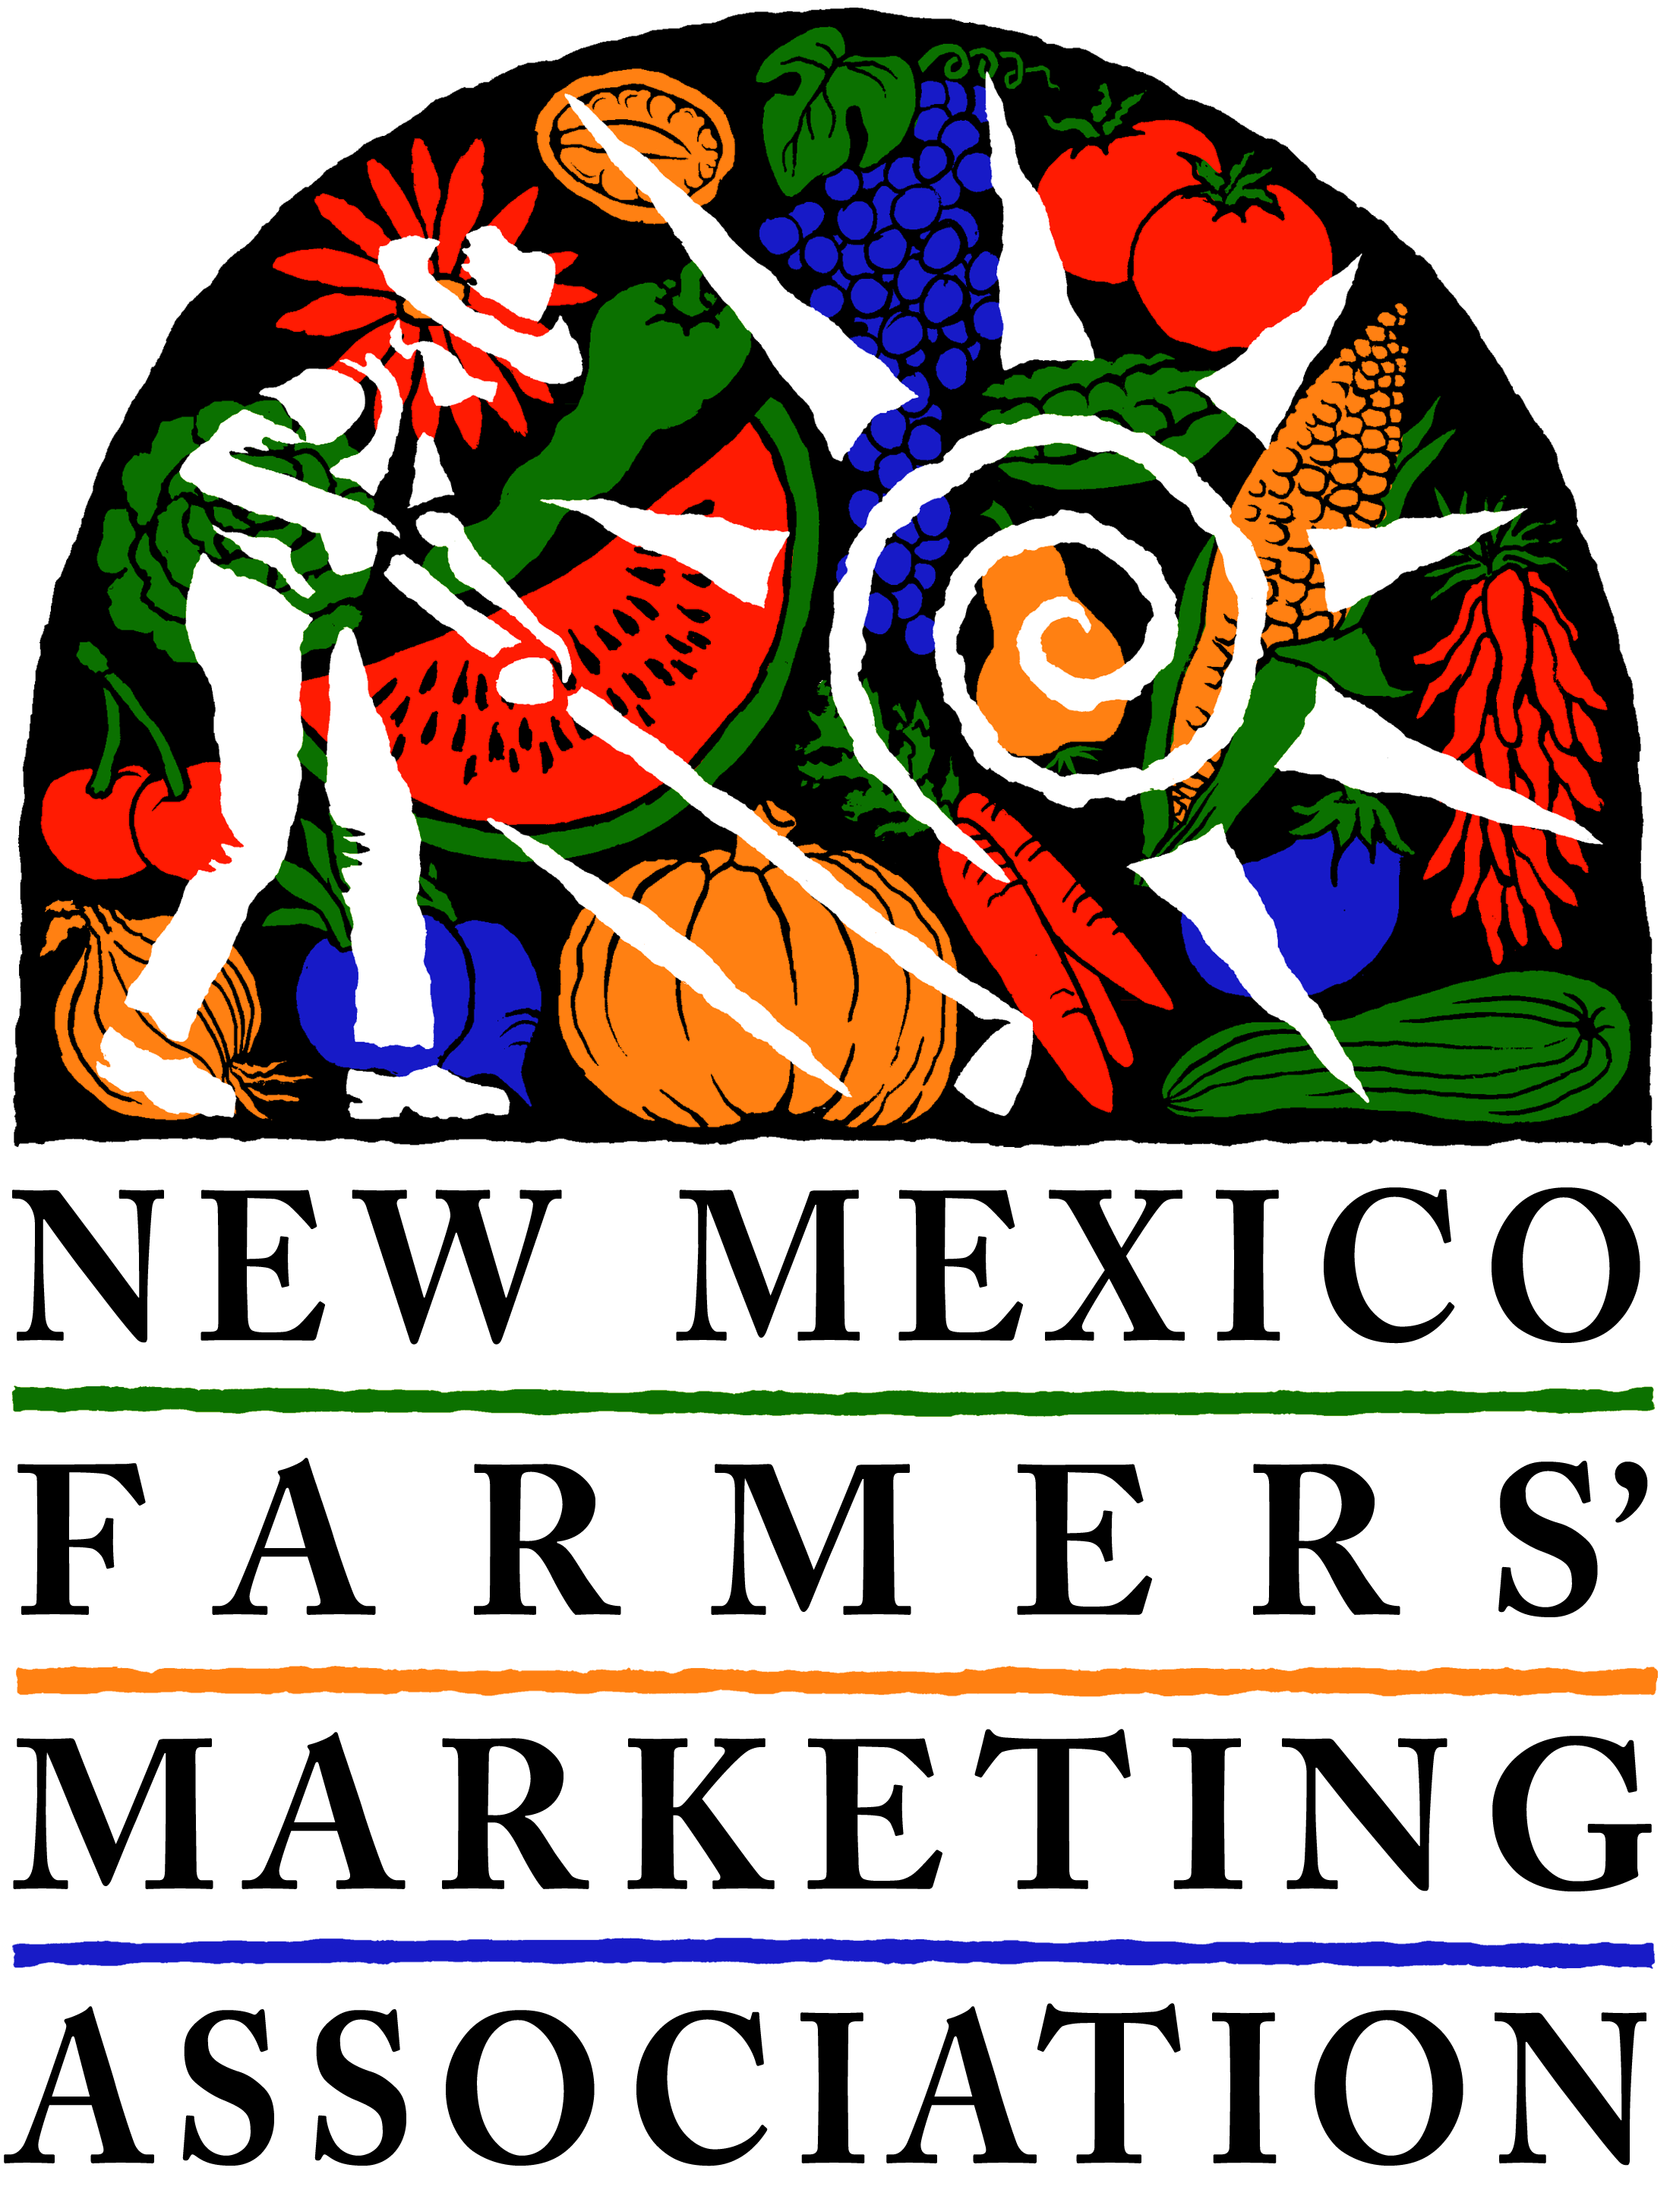
GRANT APPLICATION
Local Innovation Farmer Enterprise (LIFE)

DEADLINE: MARCH 15, 2019

NOTE: If submitting electronically, you may use as much space as needed within the text boxes. OR, you may print the form, fill it in, and use extra pages as needed. Email or snail mail to the address on Page 2. We will reply via email to let you know we received your application. If you don’t hear from us, please call.

1. Your name

2. Your farm name

3. Farm location (town, city, or county)

4. How many acres do you typically farm for vegetable/fruit production?

5. What are your three principal crops? And approximate volume of each?

Crops | Estimated Pounds per Year
#1
#2
#3

6. What kind of project do you have in mind? (Please check)

________ Wholesale crop project ________Regenerative agriculture project

7. Project Name _____________________________________________________________________________

8. What amount of grant money are you requesting? $__________________________________
Maximum grant amount is $3,000, but smaller amounts are fine. Don’t forget, this is a cost-share project, so you will need to “match” the requested amount either with in-kind or actual spending on your end.

9. Project Description. We understand that one growing season will not be enough to measure certain results from certain projects. However, please describe what you will be able to learn within one growing season.

A. Goal(s): What big picture things do you hope to learn or accomplish?

B. Timing: Why are you tackling problem or challenge now? (ie., opportunities in the marketplace, timing for your operation, etc.)

C. Deliverables/Outcomes: 1. What measureable things do you anticipate happening? 2. How will you measure it? For example, you might expect to increase your carrot production from 500 pounds to 4,000 pounds, to be measured by output and sales. Or, you might plan to improve your soil and build a bioreactor, and will test your soil before and after.

1.

2.

D. Work Plan: What activities will you be undertaking, when, and who will be responsible for the activity? Be as specific as possible. For WHEN, you can estimate month. For WHO, if you will be using a consultant or contractor but don’t know who it will be, just put “Contractor, “ “Consultant” “Hired Labor” etc. Please add lines as needed.

Activity | When | Who
1.
2.
3.
4.
5.
6.
7.
8.
9.
10.

E. Sharing: Does the project involve any sharing of resources? If so, please describe.
For example, if you intend to purchase or rent equipment, do you plan to share it with other farmers? If you are creating labels or packaging, will that be shared with any other farmers?

10. Please use the Budget Template provided to show how the grant will be used, and what your sources of “match” are. Be as specific as possible for all costs. Use hourly rates, mileage, and specific cost estimates. Use the Budget Template EXAMPLE for guidance.

11. How do you hope to incorporate results of this project into your future farming business?

GRANT DEADLINE: March 15, 2019
QUESTIONS? E-mail or call Denise Miller, dmiller@farmersmarketsnm.org, 505-699-2064,
OR Sarah Grant, sarahg@farmersmarketsnm.org, 505-983-4010 x2

NMFMA • 1219 Luisa, Unit 1 • Santa Fe, NM 87505

